Multiple Sequence Alignment Using Evolutionary Programming
Chellapilla, K. and Fogel, G.B.
Proceedings of the 1999 Congress on Evolutionary Computation, 1999. CEC 99.
Volume: 1 , 1999 , Page(s): 445 –452
- Abstract
Current multiple sequence alignment algorithms work well for sequences with high similarity but do not scale well when either the length or number of the sequences is large or if the similarity is low. The focus of this paper is to develop an evolutionary programming(Ep) algorithm for multiple sequence alignment.
- Initialization
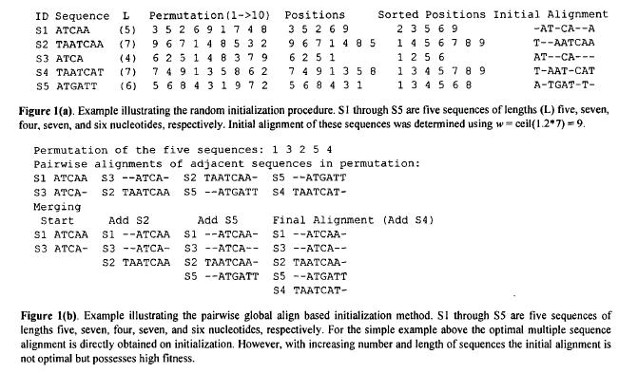
- Variation
Five possible variation operators.
-RandomShuffle
-LocalShuffleone
-GrowMatchedCol
-RecombineMatchedCol
-LocallyAlignBlock
The corresponding probabilities of selecting each operator were 0.4, 0.3, 0.1, 0.1, and 0.1, respectively.
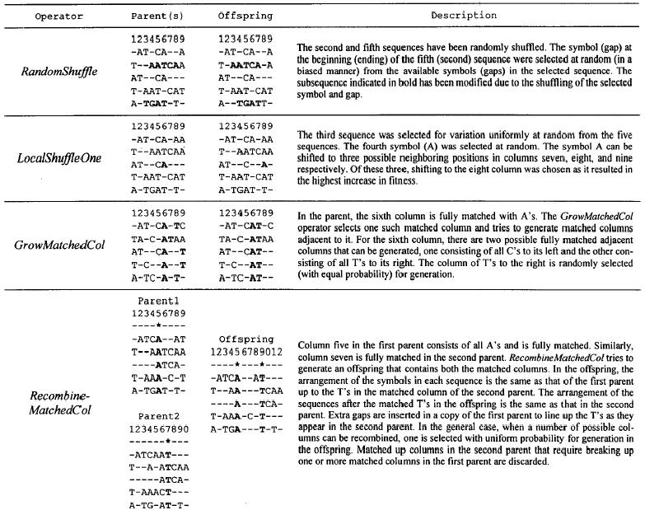
- Fitness Evaluation
Fitness = SymbolScore – GapScore
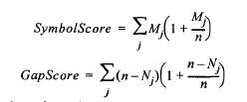
- Results
Created by : Ming-Cheng Lin
Date : Apr 18, 2000

